Section 1: Collection Creation

These screenshot are to showcase the creation of each content type using strapi.

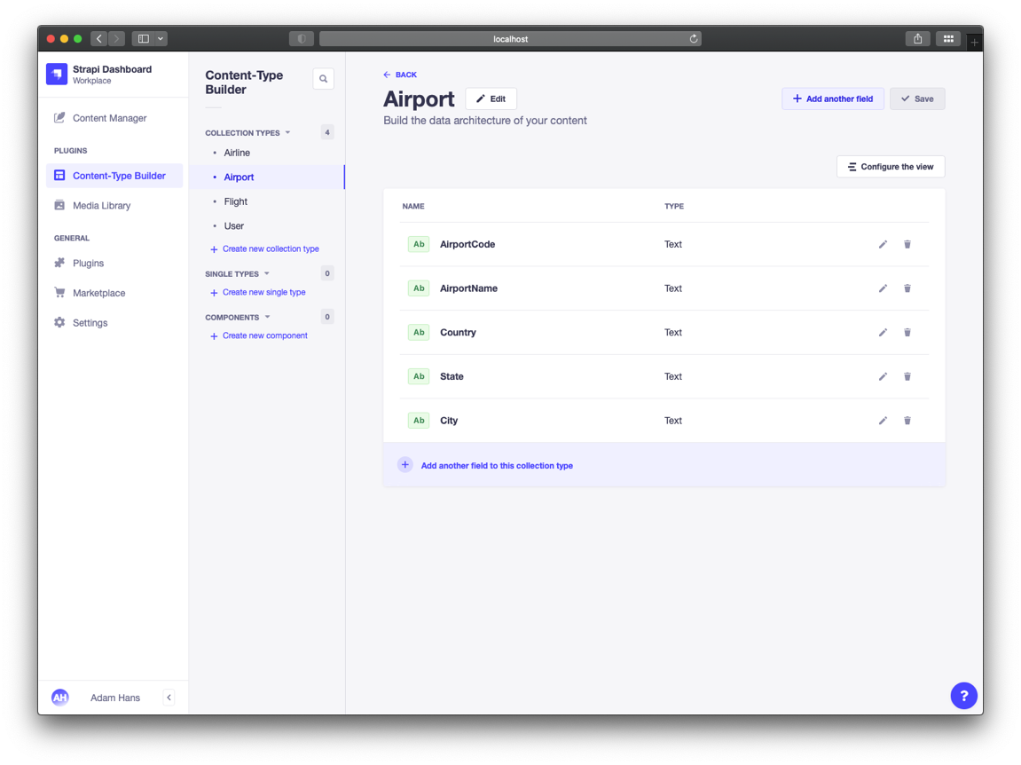

Figure 1: Airport Collection

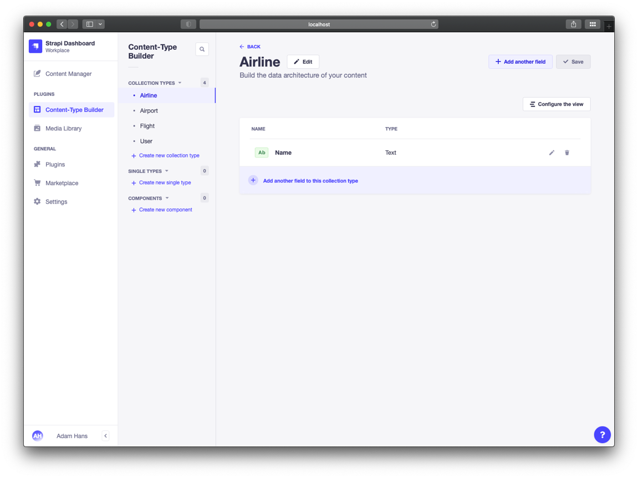

Figure 2: Airline Collection

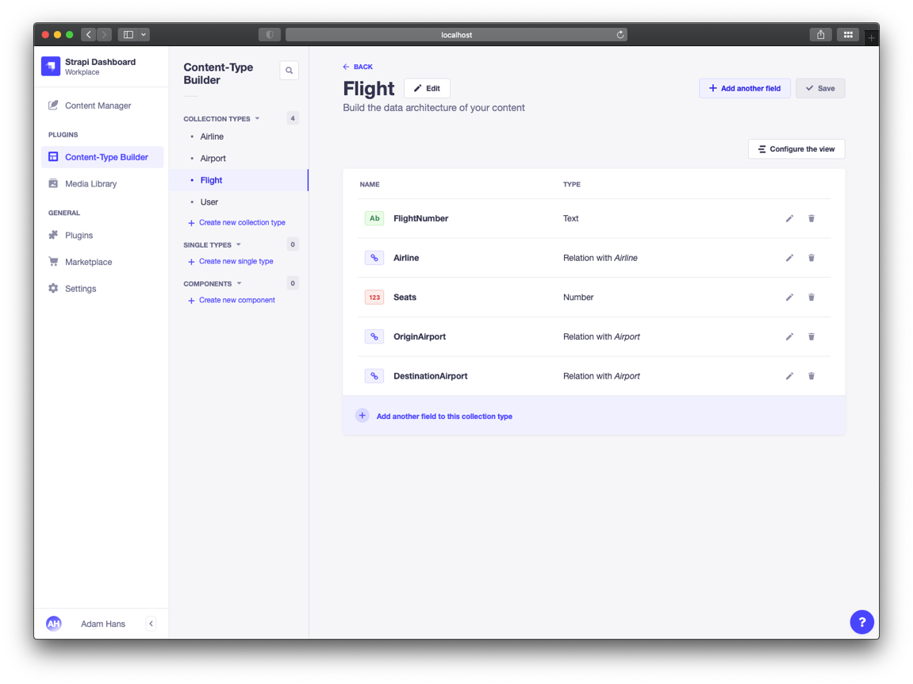

Figure 3: Flight Collection

Section 2

Below are the screenshots for each of the localhost:1337/api/ tables that were created and posted via strapi.

Figure 4: URL for Flights

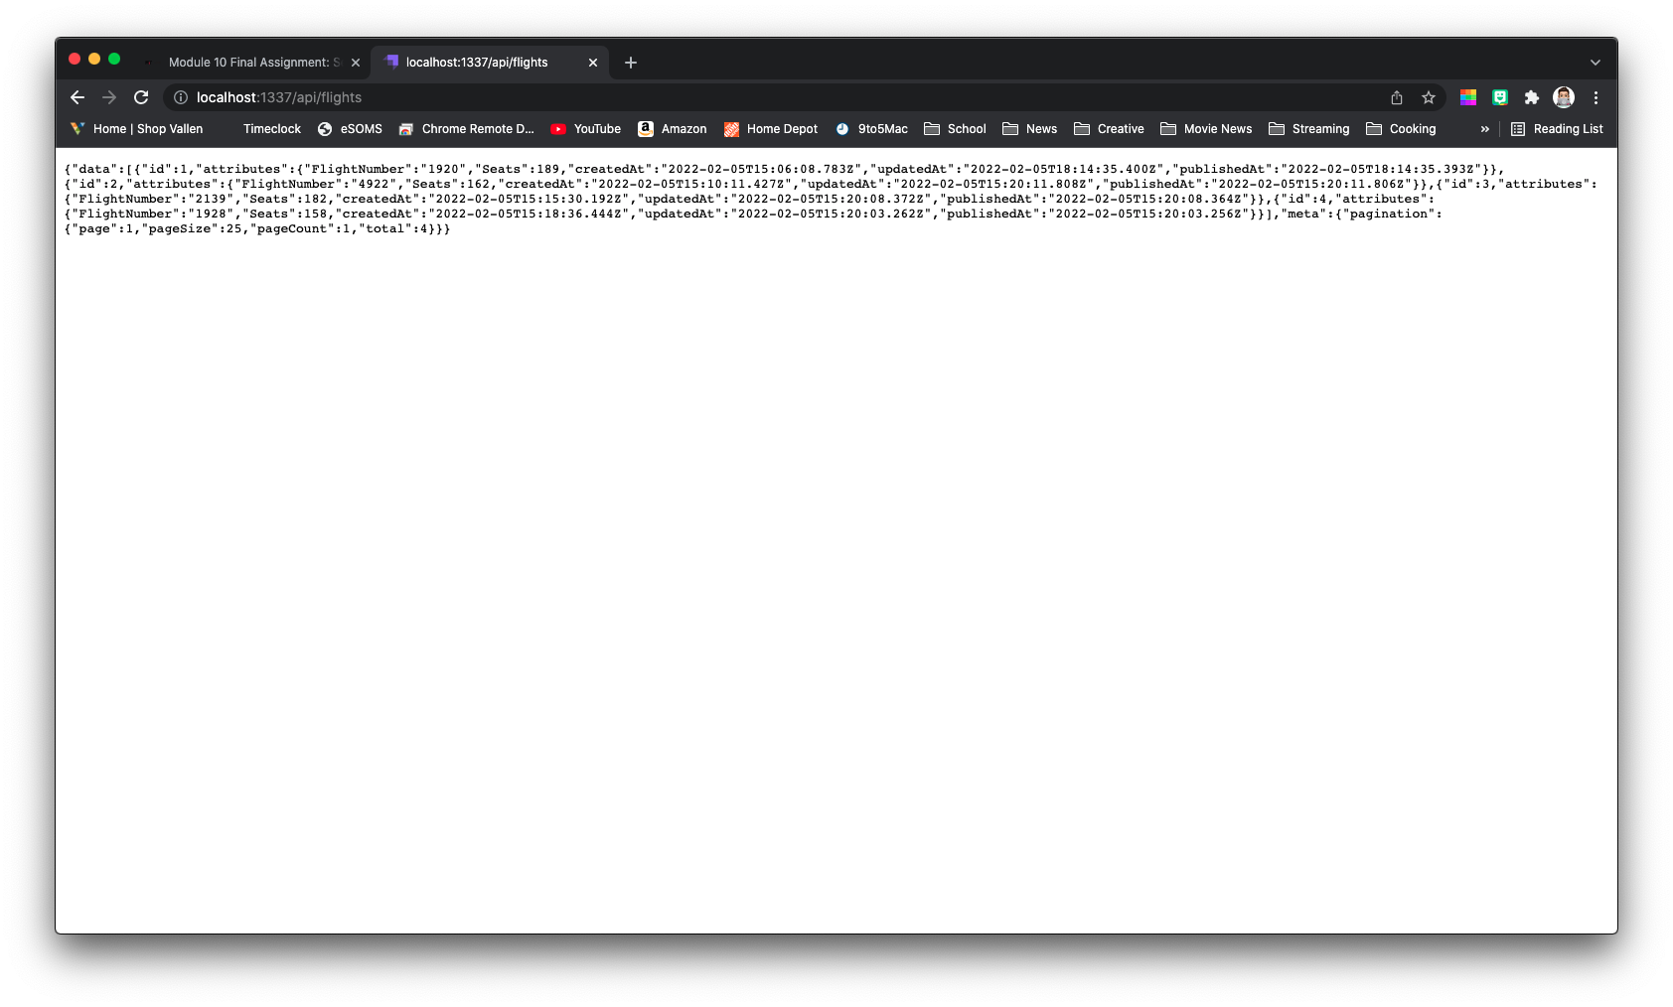

Figure 5: URL for Airports

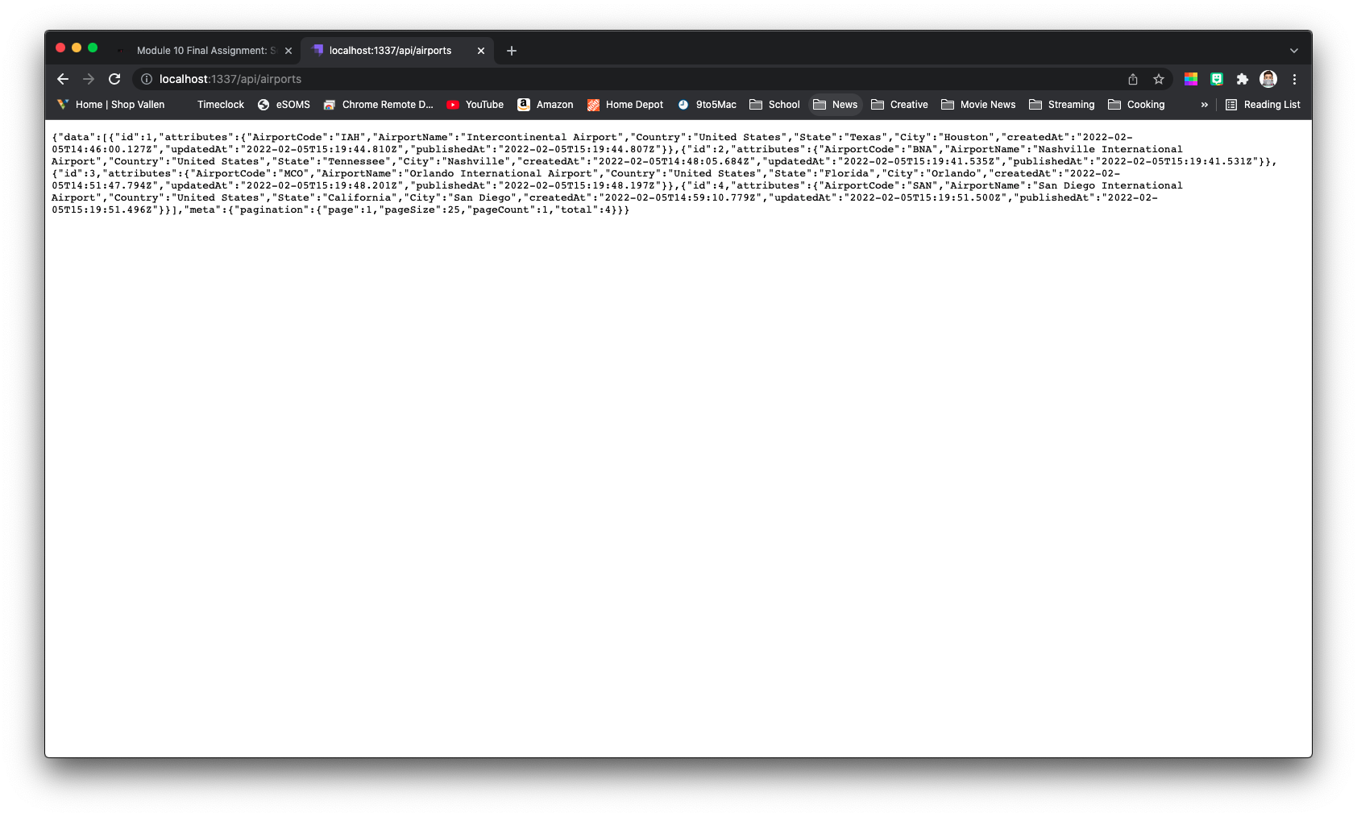

Figure 6: URL for Airlines

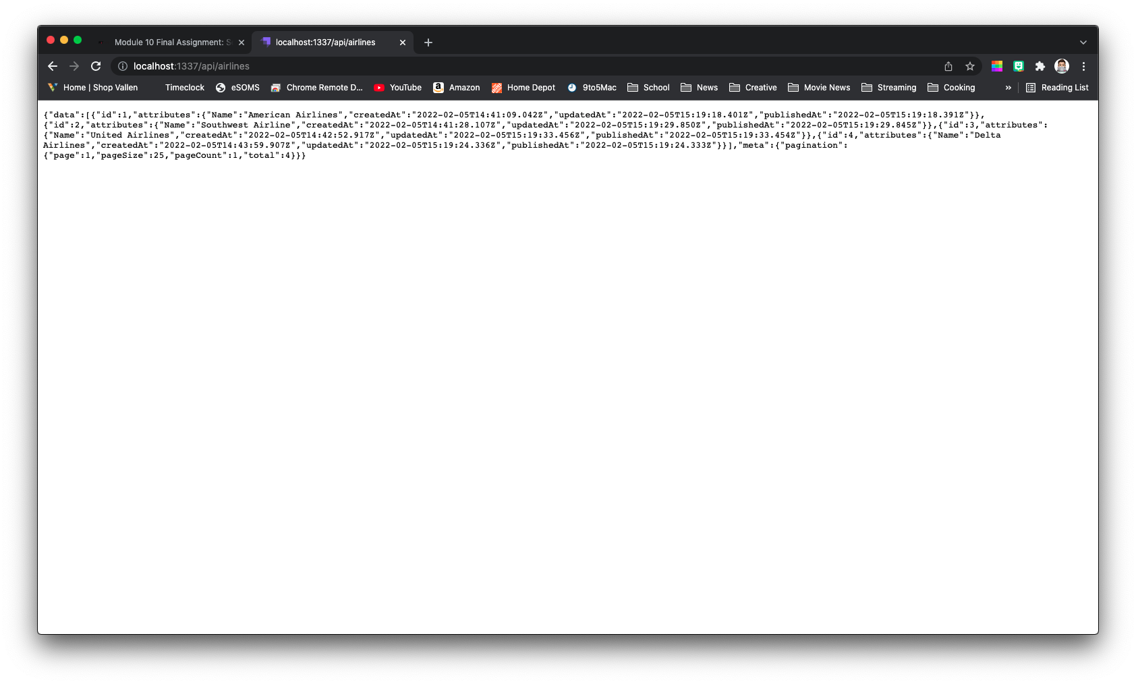

Section 3: Postman

Using Postman, send a GET *request*to retrieve all of the data from your Flights application.

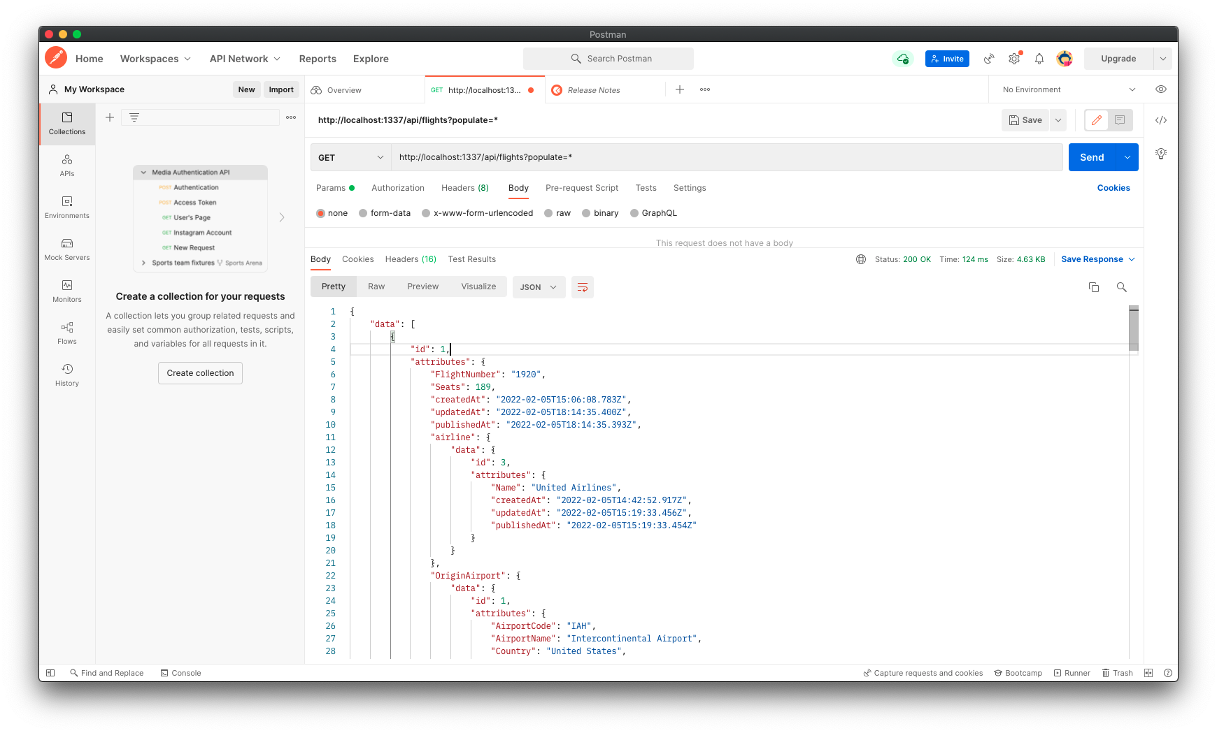

Section 4

Using Postman, send a GET request to get the flight with id = 1

Figure 7: GET Request for Flight ID 1 wo relationship

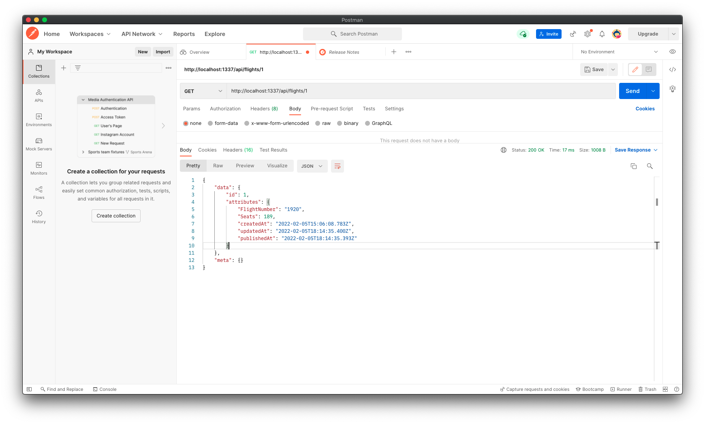

Figure 8: GET Request for Flight ID 1 w/ Relationships

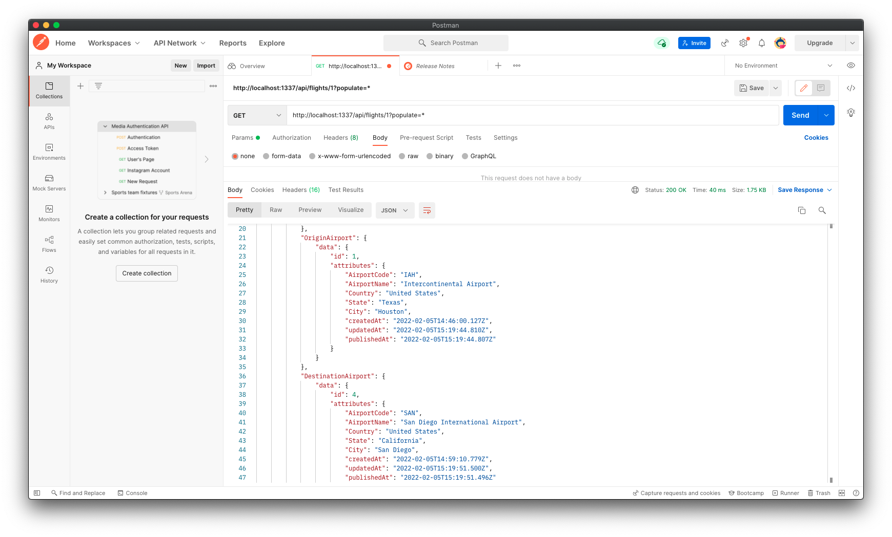

Section 5

Using Postman, make a POST *request* to create a new flight.

Figure 9: POST Request to create a new flight

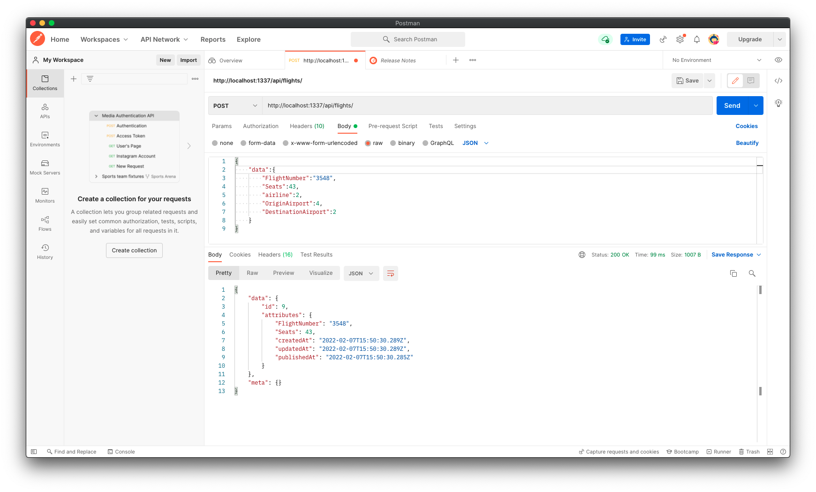Section 6

Point your browser to the Flights *Collection* and include a screenshot of the browser to show that a new flight has been created

Figure 10: URL for New Flight Created

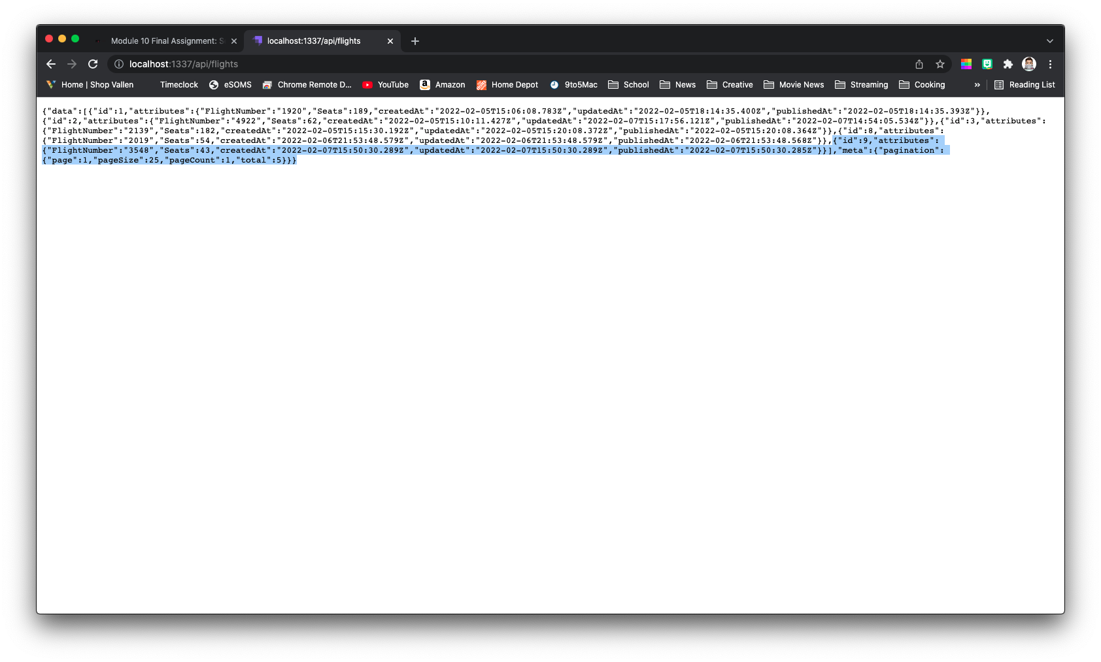

Section 7

Using Postman, send a POST *request* to update a flight from your Flights application

Figure 11: Flight ID 2 (Need to Update Seat Count)

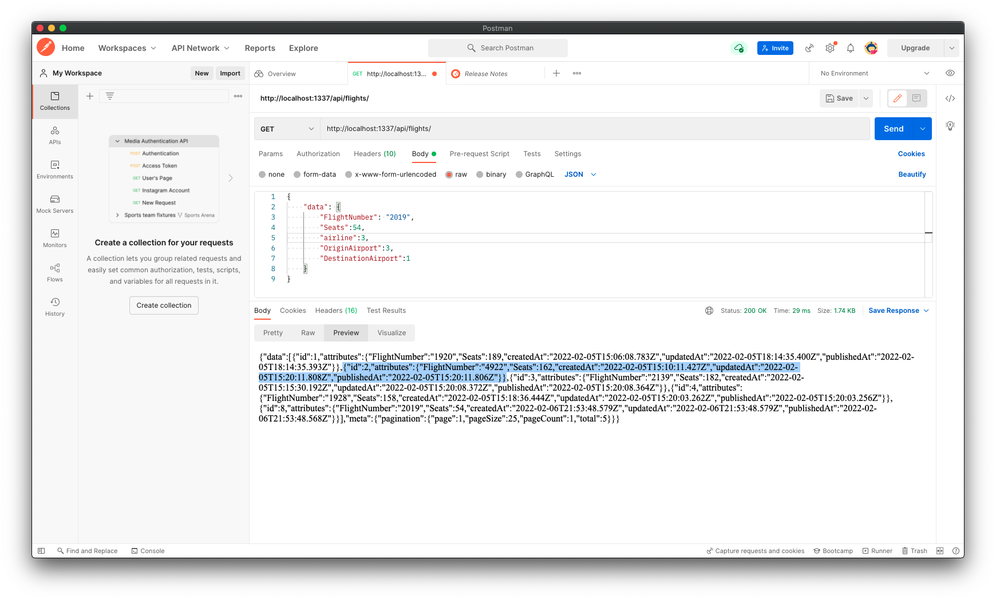

For this example, I noticed the second entry for flights, showed the seats are listed as 162. This is incorrect and should read 62. I will use a PATCH request to update this field.

Figure 12: Put Request Shows Seat Count Update Successful

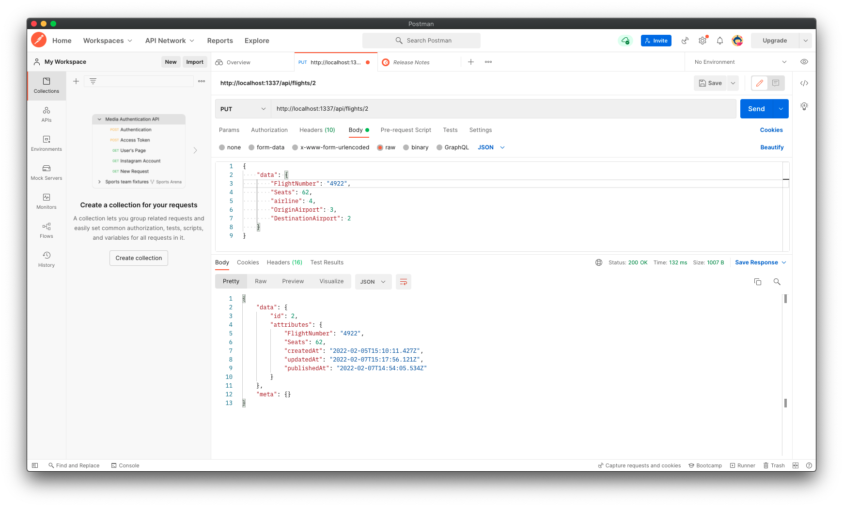

Section 8

Point your browser to the Flights *Collection*and to show that the flight has been updated.

Figure 13: Browser Window to show Flight 2 Seat Count Updated

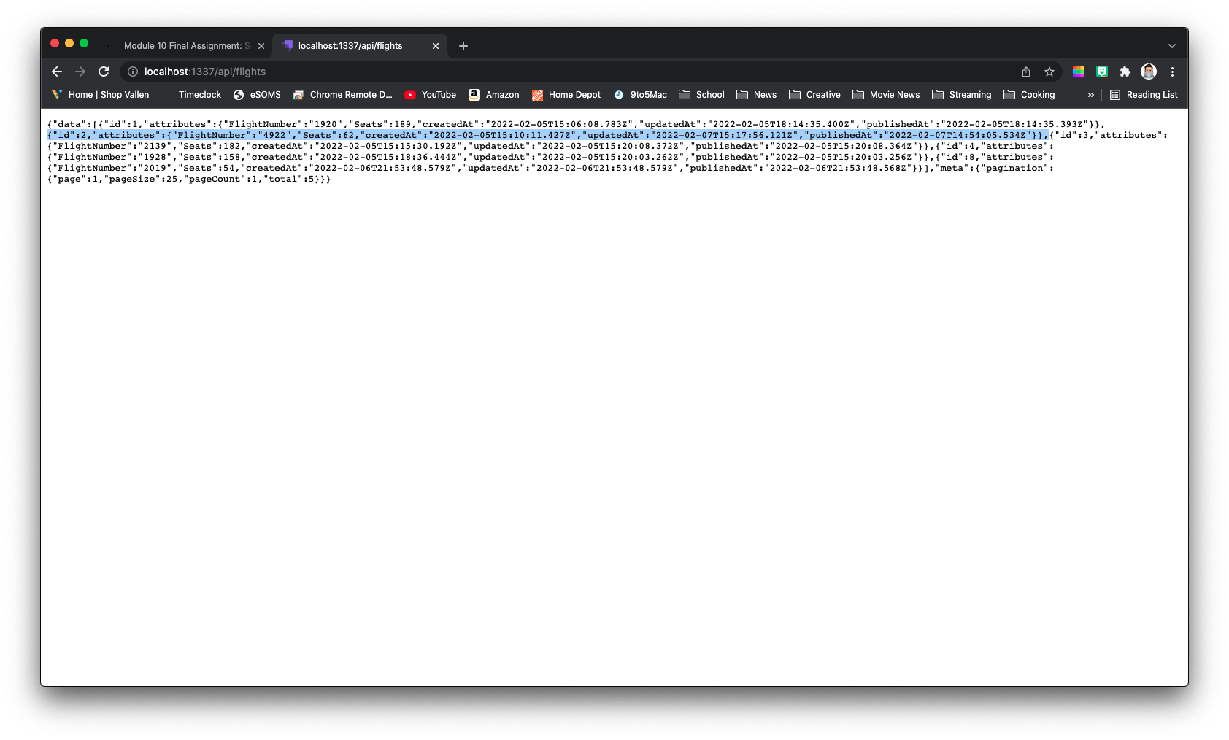

Section 9

Using Postman, send a DELETE*request* to delete a flight from your Flights application

Figure 14: Flight 4 Delete Request Successful

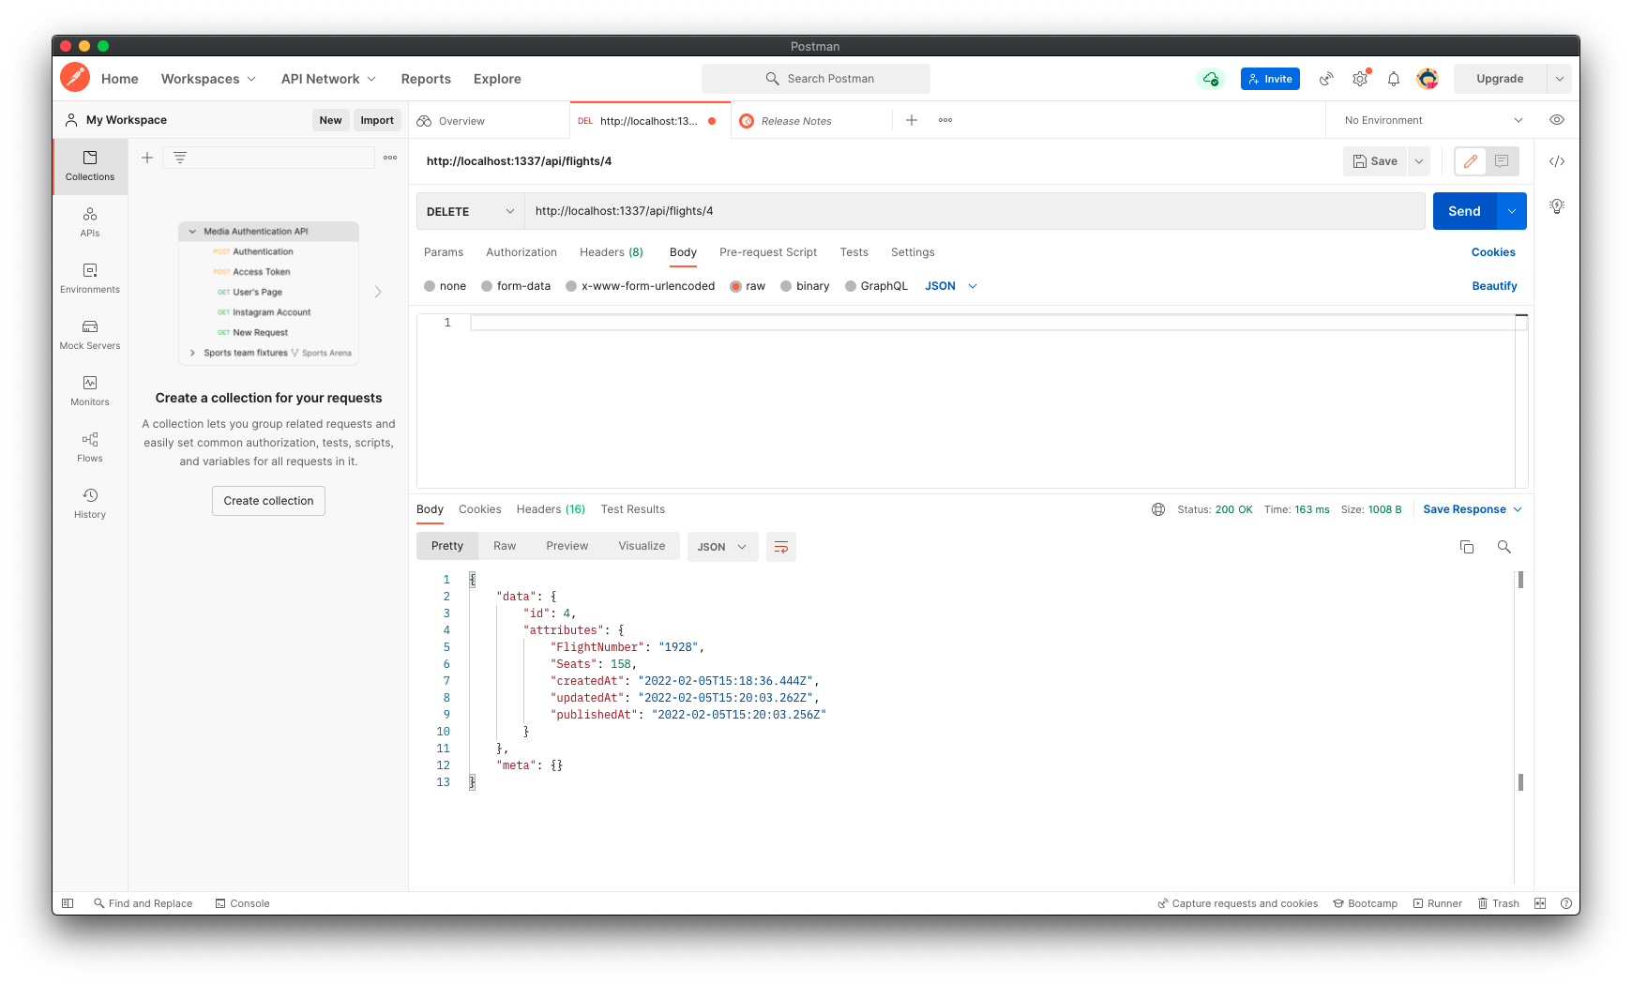

Section 10

Point your browser to the Flights *Collection* and include a screenshot of the browser to show that the flight has been deleted

Figure 15: Browser Window Showing Flight 4 Deleted

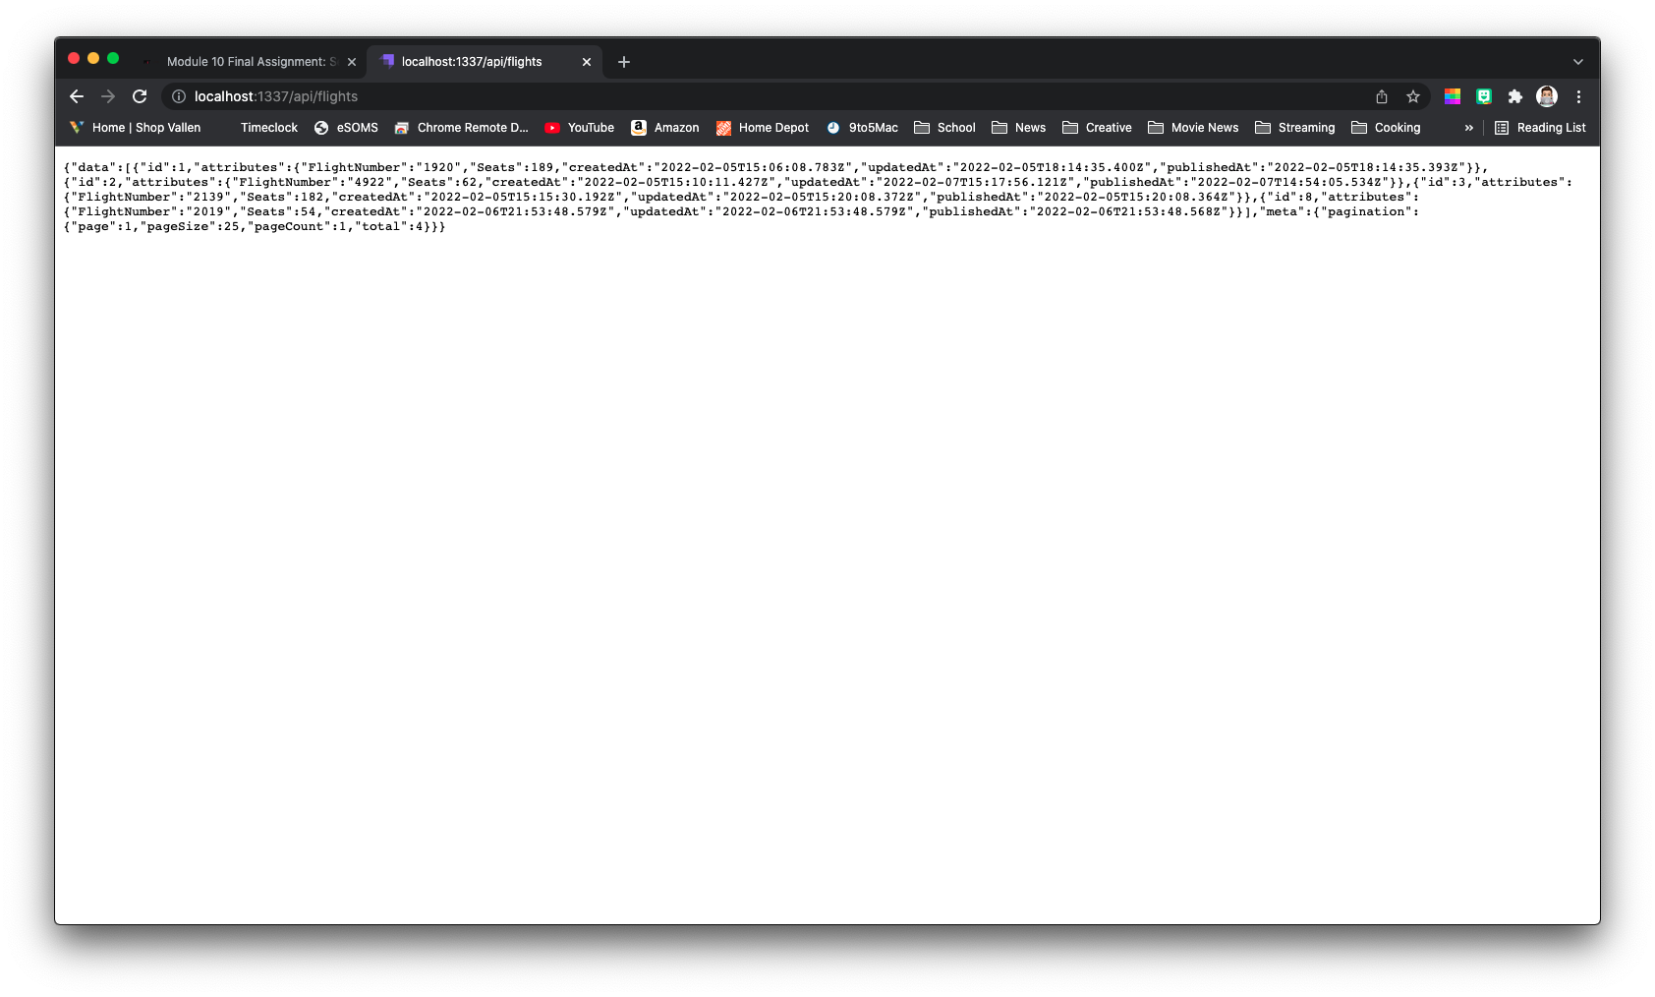

Section 11

Using Postman, obtain the code to create a Python application to make a GET *request* to your airline application. Run the code in VS Code and see the results.

Figure 16: Postman GET Request Code Window

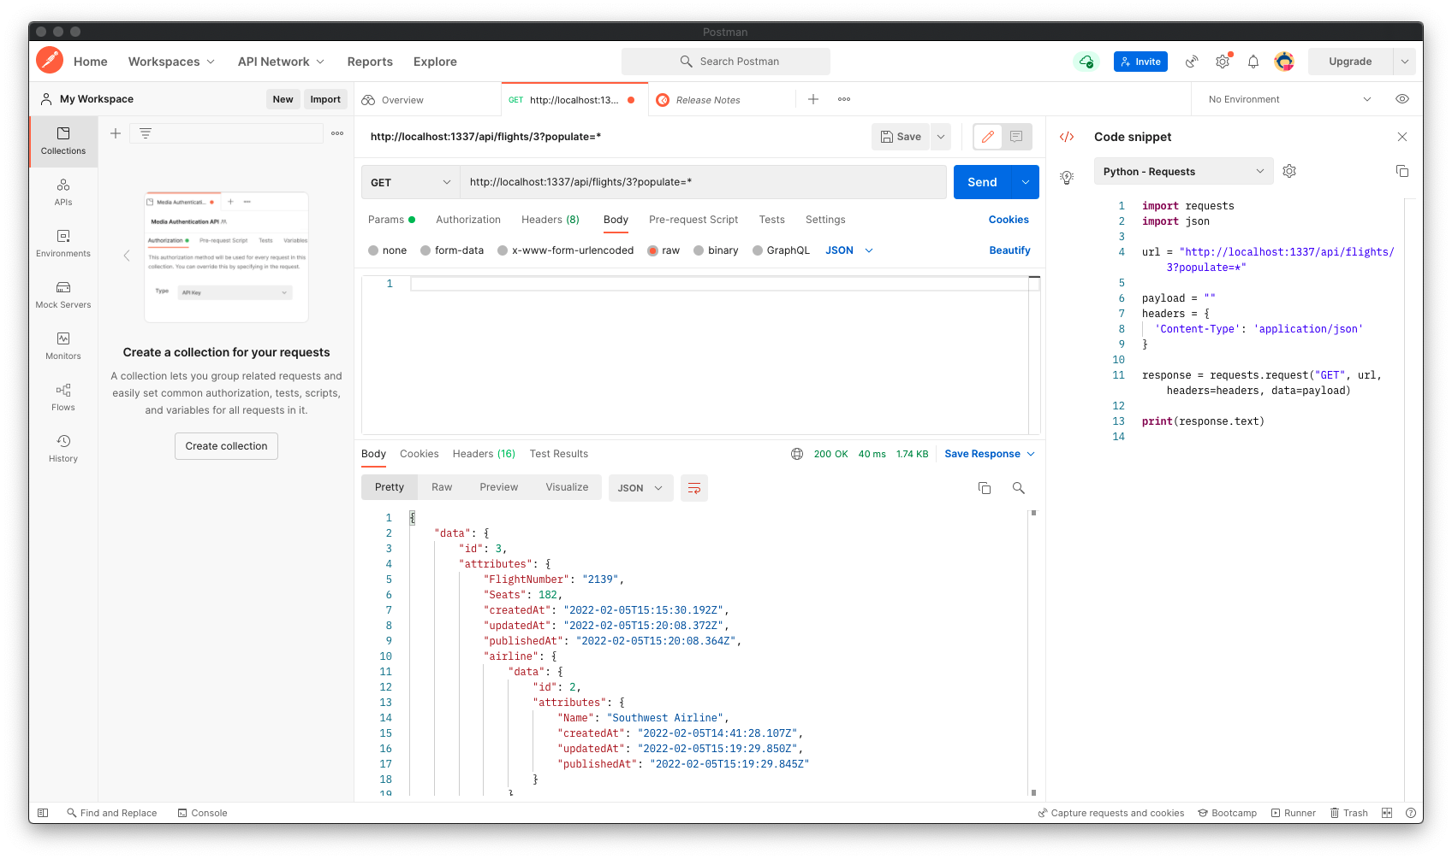

Figure 17: VS Code Python Request for Flight 3 and Terminal Window Output

